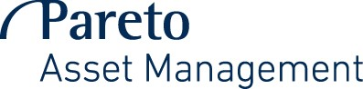

Application form for redemption

(Compulsory columns *)
Last name, First name/Legal entity person * | Social security number/Reg number *  (for legal company a certificate of registration is needed)
Street * | Postal code, City *
Country (if not Sweden) | Phone number *
Fund name and ISIN code | Number of shares / Percentage of shares / Amount

Please sign

……………………………………………………….
City, date

………………………………………………………
Signature

……………………………………………………….

The application form could be sent by post to:
Pareto Asset Management AB, Box 2165,
103 14 Stockholm
or faxed to (+46) 08-790 57 50.

The amount will be sent to your bank account that has been listed in our records.

Clarification of signature
(An administrator signature is necessary if the shareholder is under age)

More information about our funds can be found on our webpage.
For information about your holdings please contact Operations.

If any questions please contact Operations: (+46) 08-790 57 00.

